**Children’s Details Lyminge Pre-school **

|  |
| --- |
| **Child’s Name: Male/female** |

|  |  |
| --- | --- |
| **Child’s preferred name if different from above** | **Legal name if different from above:** |

|  |
| --- |
| **D.O.B** |

|  |
| --- |
| **Address:** |

**Parent’s details**

|  |  |
| --- | --- |
| **Parent 1**  **Phone:**  **Email:** | **Parent 2**  **Phone:**  **Email:** |

**Who has legal parental responsibility.**

|  |  |
| --- | --- |
| **Parent 1 yes/no** | **Parent 2 yes/no** |

**How do parents wish to be addressed.eg Mr, Mrs, first names. etc**

|  |  |
| --- | --- |
| **Parent 1.** | **Parent 2** |

**Who to contact in an emergency in addition to parents if applicable:**

|  |
| --- |
| **1st Emergency contact name:**  **Phone number:**  **Relationship to child.** |
| **2nd Emergency contact name:**  **Phone number:**  **Relationship to child.** |
| **Child’s GP. Name and phone number:**  **Has your child had their 2 year check with the Health Visitor? YES/NO** |

|  |
| --- |
| **Were there any difficulties at birth?** |

**Tick vaccines had (these are are all in your child’s red book)**

|  |  |  |  |  |  |  |  |  |  |  |
| --- | --- | --- | --- | --- | --- | --- | --- | --- | --- | --- |
| Measles | Mumps | Rubella | MMR | HIB | Polio | Tetanus | Diptheria | Men C | W/cough | Pn’coccal |

**Tick any illnesses had or have**

|  |  |  |  |  |  |  |  |
| --- | --- | --- | --- | --- | --- | --- | --- |
| Chicken pox | Measles | Mumps | Rubella/German measles | Whooping cough | Convulsions/fits | Asthma | Glue ear |

|  |
| --- |
| **Any allergies, medical conditions, operations, or home situations that the practitioners need to be aware of?** |

|  |
| --- |
| **Name any other agencies involved with your child** |

|  |  |  |
| --- | --- | --- |
| **Religion:** | **Ethnic origin:** | **First language:** |

|  |  |  |
| --- | --- | --- |
| **Password for others collecting your child:** | **Attends another nursery/preschool/child minder?** | **Second language ( if any):** |

|  |  |  |
| --- | --- | --- |
| **Signed** | **Print name** | **Date** |

Has your child had their 2 year health check with your health visitor? Yes/No (delete)

Does your child attend another setting or childminder? Yes/No (delete)

If Yes and your child is 3+ have they had their developmental progress check

with another childcare provider? Yes/No (delete)

Are you eligible for the Early Years Pupil Premium Funding (EYPP – See

information sheet enclosed?) Yes/No (delete)

Are you eligible for the Free Early Education for 2 Year Olds (FF2 – See

information sheet enclosed?) Yes/No (delete)

**How did you find out about Lyminge Pre-School?**

|  |
| --- |
|  |

**Session Attendance**

Start Date **___________________________________**

|  |  |  |  |  |  |  |  |  |
| --- | --- | --- | --- | --- | --- | --- | --- | --- |
|  | Brkfst  Club  8 - 9 | 9-12 | 9-1 | 12-3 | 9-3 | Twilight  3-4 | Twilight  3-5 | Twilight  3-6 |
| Monday |  |  |  |  |  |  |  |  |
| Tuesday |  |  |  |  |  |  |  |  |
| Wednesday |  |  |  |  |  |  |  |  |
| Thursday |  |  |  |  |  |  |  |  |
| Friday |  |  |  |  |  |  |  |  |

**Your child’s birth certificate or passport must be seen to confirm your place at Lyminge Pre-School. Please be advised that this application form and offer of a place is subject to our terms and conditions provided to you. By signing this document, you acknowledge that you have read, understood and agree to our terms and conditions.**

|  |  |  |  |
| --- | --- | --- | --- |
| Signed by (print name) | | | |
| Parent / Carer |  | Date |  |

**Permission and Consents**

|  |  |  |  |  |
| --- | --- | --- | --- | --- |
| **Emergency Aid Consent** | | | | |
| Name of Child |  | | | |
| In the event of illness or accident and in parental absence I hereby authorise Lyminge Pre-School to take any necessary action to provide or consent to emergency aid with regard to my child’s medical care and attention. | | | | |
| Signed by (print name) | | | | |
| Parent / Carer | |  | Date |  |

|  |  |  |  |  |
| --- | --- | --- | --- | --- |
| **Outings Consent** | | | | |
| Name of Child |  | | | |
| I authorise Lyminge Pre-School’s appointed staff/helpers to accompany my child on visits and outings away from the site of Lyminge Village Hall to include;   * Local walks around the village during session time. * Visits to local amenities within the village. * Organised outings incorporating the use of public transport or private hire vehicles. Specific information regarding trips away from the locality will be provided by Lyminge Pre-School before taking place.   Ofsted regulations regarding supervision ratios will be strictly adhered to at all times, and child medical information will be reviewed and considered prior to departure. | | | | |
| Signed by (print name) | | | | |
| Parent / Carer | |  | Date |  |

|  |  |  |  |  |
| --- | --- | --- | --- | --- |
| **Sun Cream Application** | | | | |
| Name of Child |  | | | |
| I consent to Lyminge Pre-School’s appointed staff/helpers re-applying sun cream, provided by myself, during session times. | | | | |
| Signed by (print name) | | | | |
| Parent / Carer | |  | Date |  |

|  |  |  |  |  |
| --- | --- | --- | --- | --- |
| **Observation and Assessment Records and use of images of children** | | | | |
| Name of Child | ___________________________________________________ | | | |
| Observations both written and photographic are made and recorded regularly by your child’s key person/staff and are used for assessment and planning purposes.  We may use photographic images in our prospectus or in other printed publications that we produce, as well as on our website. We may also make video or webcam recordings for monitoring or other educational use. We will not use the personal details or full names (which means first name and surname) of any child in a photographic image on video, on our website, in our prospectus or in other printed publications.  From time to time we may be visited by the media who will take photographs or film footage of an event. Children may appear in these images, which may appear in local or national newspaper, or on televised programmes.  This permission is valid from the date you sign it for the period of time your child attends Lyminge Pre-School. | | | | |
| Signed by (print name) | | | | |
| Parent / Carer | |  | Date |  |

**Babysdays Online Profile**

Baby’s Days is the system we use for recording your child’s progress, uploading photographs of your child and plans for their next steps. We also use the system for producing diaries, assessments, 2 year checks, monitoring children’s progress and statistics. It is an amazing system and all parents receive their own password which ensures the system is protected and secure.

Please sign below to allow us to send you your personal log in details and get started.

I agree to all details on the Lyminge Pre-School registration form to be transferred to the Baby’s Days system on the understanding that all information is securely password protected and no one apart from staff at Lyminge Pre-School will access to this information.

|  |  |  |  |
| --- | --- | --- | --- |
| Signed by (print name) | | | |
| Parent / Carer |  | Date |  |
|  | | | |
| **Please do not hesitate to talk with the Manager concerning any queries you may have regarding these consent forms, or detail below any exceptions you may have** | | | |

.

**New Child’s First Profile **

**Name of child:………………………………………………………………………..**

Dear Parents,

In order for us to get to know your child and to make their start as easy as possible please could you answer the questions below? Many thanks ☺

|  |  |
| --- | --- |
| Does your child have any siblings? If so what are their ages? |  |
| Has your child attended another setting? Child minder? Have they attended a Toddler Group? |  |
| Has your child had their 2 year check with the health visitor. If not have you had an appointment through? |  |
| What do they particularly like doing? |  |
| Do they have a comforter? |  |
| What are they looking forward to doing at Pre-School? |  |
| Is there anything that they do not like or are scared of? |  |
| How are their communication skills? |  |
| How are their physical skills? |  |
| Do they like to be outdoors or prefer to play indoors? |  |
| Does you child like to get messy? |  |
| Can they go to toilet independently? |  |
| How confident are they? Are they outgoing or shy? |  |
| Do they have an extended family that they see regularly? |  |
| Finally, could you please give us a little about your child’s family background. Eg does your child live with one or two parents? Do both or one parent work? What do you do if you do work?  Many thanks for taking the time to fill in this questionnaire. |  |

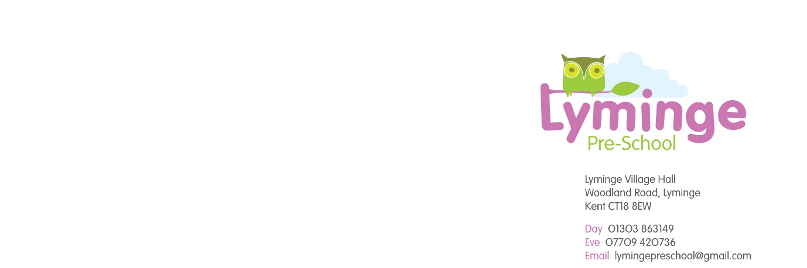

**Free Places for 2 Year Olds**

Free early education places for 2 year olds is known in Kent as the Free for 2 or 'FF2' scheme.

The local authority has a duty to provide eligible 2 year olds up to 570 hours of free early education a year over 38 weeks of the year. These 38 weeks are in line with our [school term dates](http://www.kent.gov.uk/education-and-children/schools/term-dates).

A child is eligible if:

* they come within the criteria used to determine eligibility for Free School Meals
* their families receive Working Tax Credits and have an annual gross income of no more than £16,190 per year
* they have a current statement of Special Educational Needs or an Education, Health and care plan
* they are entitled to Disability Living Allowance
* they are looked after by a local authority
* they are no longer looked after by the local authority as a result of an adoption order, a special guardianship order or a child arrangements order which specifies with whom the child lives.

Eligible children can start claiming after they turn 2, depending on when their birthday is.

| **Child's 2nd birthday** | **When they can claim from** |
| --- | --- |
| 1 January to 31 March | the beginning of term on or after 1 April |
| 1 April to 31 August | the beginning of term on or after 1 September |
| 1 September to 31 December | the beginning of term on or after 1 January |

**Example**

A child who was born on 15 February 2013 will become eligible for free early education and childcare from the start of term following 1 April 2015

Kent County Council's website has more information on [how to apply for free early education for 2 year olds](http://www.kent.gov.uk/education-and-children/childcare-and-pre-school/paying-for-childcare/free-childcare-for-2-year-olds).

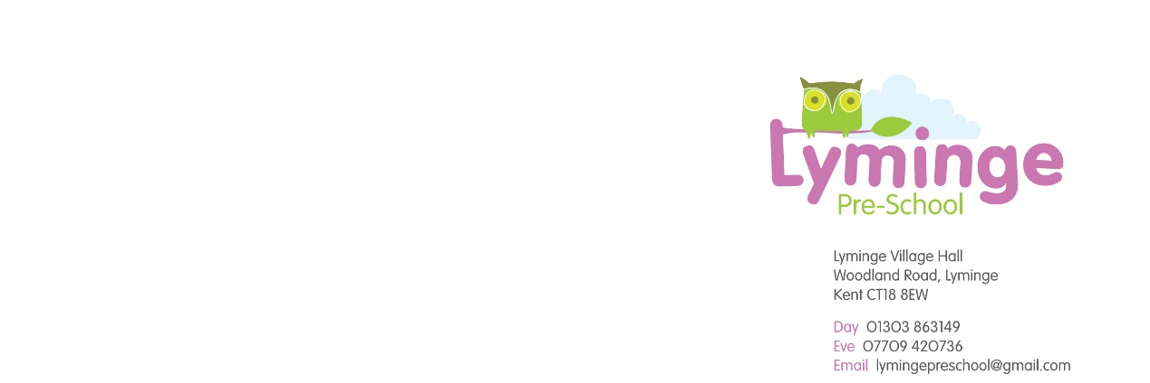

Dear Parent/Carer

**The Early Years Pupil Premium for eligible 3 and 4 year old children**

From April 2015, nurseries, schools, child-minders and other registered childcare providers will be able to claim extra funding through the Early Years Pupil Premium to support children’s development, learning and care. We wanted to write to you to explain what the Early Years Pupil Premium is, who is eligible for this funding and, importantly, to ask you to fill out the online form so that we as a provider can claim the extra funding.

The Early Years Pupil Premium provides an extra 53 pence per hour for three and four year old children whose parents are in receipt of certain benefits or who have been in care or adopted from care. This means an extra £302 a year for each child taking up the full 570 hours free early education. This additional money could make a significant difference to your child’s attainment in the future.

Wecan use theextra fundingin any way we choose to improve the quality of the early years education that we provide for your child.

It is well documented that high quality early education can influence how well a child does at both primary and secondary school so we do want to make the most of this additional funding. You may be aware, if you have older children that a pupil premium has been available for school age children and it has proved to have given a real boost to the children’s attainment. We want to do the same for our early years children who are entitled to this funding.

**Eligibility criteria - family are in receipt of the following:**

* + Income Support
  + Income-based Jobseeker’s Allowance
  + Income-related Employment and Support Allowance
  + Support under part V1 of the Immigration and Asylum Act 1999
  + The guaranteed element of State Pension Credit
  + Child Tax Credit (provided you’re not also entitled to Working Tax Credit and have an annual gross income of no more than £16,190.00)
  + Working Tax Credit Run-on (this is paid for 4 weeks after they stop qualifying for Working Tax Credit)
* Children who have left the care of a local authority as a result of an adoption order in England or Wales
* Children who have left the care of a local authority as a result of a special guardianship order in England or Wales
* Children who have left the care of a local authority as a result of a child arrangements order in England or Wales
* Children who have been looked after by a local authority for 1 day or more in England or Wales

If you feel that you meet one of the criteria above, please complete an online application form.

Please go to [www.kent.gov.uk/pupilpremium](http://www.kent.gov.uk/pupilpremium) to complete the application form.

You will need the following information:

URN (unique reference number) 519683

Alternatively you can sign a form available at the setting authorising us to complete the online application on your behalf.

When you have completed the application form you will be given a reference number which you should make a note of. Please could you give this number to us so we are aware that you have made your application.

If you are applying for the EYPP because your child has been adopted from care you must let us have evidence of the adoption (please note that sensitive information should be hidden).

Your application will be received by KCC Management Information who will carry out the necessary checks to ensure that your child is eligible for the EYPP funding. Should the checks show that your child is not eligible we will contact you to check the information received is correct. Please be aware that economic eligibility criteria for 3 year olds need to be checked again in the September of the academic year that the child will turn 4.

EYPP funding is paid direct to the setting to improve your child’s learning experience; there is no monetary value for parents.

If you have any questions, please contact Alison Maddison-Roberts.



**LYMINGE PRE-SCHOOL FEES STRUCTURE**



At Lyminge Pre-School we believe in open communication with all parents/carers and are presenting this fees structure in order to ensure that everyone fully understands our charging. Our fee structure is fully inclusive of all drinks and snacks. We are open for 38 weeks per year, closing on Bank Holidays. Our fees do not include any outings, celebrations, entertainment or additional services provided that are in addition to our usual session activities.

**FEES:** Fees are payable monthly in advance, in accordance with the rates in force at the time. Fees are reviewed annually or in the event of any changes to the Code of Practice. Any changes to current rates will be advised in writing, at least one month in advance.

|  |  |
| --- | --- |
| Full Day 9am-3pm | £30.00 |
| Morning Session 9am-12pm | £15.00 |
| Morning Session 9am-1pm | £20.00 |
| Afternoon Session 12pm-3pm | £15.00 |
| Hourly Rate (extended sessions) | £5.00 |
| Breakfast Meal (charged in addition to the session fee for children starting at 8am or 8:30am) | £1.50 |

**ILLNESS/ABSENCE:** No refund will be given in the event of a child’s absence due to illness, holiday or any other reason because the pre-school is obliged to commit to staff and overhead costs months in advance which cannot be retrieved.

**CLOSURES:** Should the pre-school be unable to open due to bad weather or any other unforeseen circumstances, parents will not be refunded for a chargeable session or have it discounted from their next invoice. Should closure need to take place part way through a session, a refund will not be given in this instance.

**LATE PICK UP:** Children must be collected promptly at the end of a session/day. Should a parent fail to collect their child within 10 minutes of the session/day end, we reserve the option to charge a late collection fee of £5, and a further £25 per every half hour thereafter.

**LATE PAYMENTS:** Fees are to be paid within 2 weeks of the invoice date. If you are experiencing financial hardship please speak, in confidence, to the manager so that alternative payment arrangements can be made. If without negotiation, fees are not settled, we are left with no alternative but to withdraw your child’s place and if necessary take legal action to recover the amount owed. Children in receipt of Free Early Education will be unable to access any additional fee paying hours until outstanding fees are settled.

We ask for a £40 non-refundable registration fee in advance of acceptance of the place. A registration fee is NOT required for children who are only accessing the Free Early Education.

**PAYMENT METHODS:** Invoices can be settled by cash, cheques or BACS transfer. Please make cheques payable to Lyminge Pre-School.

**FREE EARLY EDUCATION (FEE):** The following information details how your child can access their FEE hours at Lyminge Pre-School.

**FREE EARLY EDUCATION and ADDITIONAL FEES:** All children become eligible for Free Early Education the term after they become 3. Some 2 year olds may also be eligible for funding. Parents/carers are asked to check with the manager to find out if their child qualifies or access the following link to apply online :

http://www.kent.gov.uk/education-and-children/childcare-and-pre-school/free-childcare/free-childcare-for-2-year-olds

A child iseligible for FEE at the start of the term after their second (if eligible), or third birthday in line with the Department for Education table below:

|  |  |
| --- | --- |
| **A CHILD BORN ON OR BETWEEN** | **WILL BECOME ELIGIBLE FOR A FREE PLACE FROM** |
| 1st April and 31st August | Start of term 1, in September, following their 2nd/3rd birthday |
| 1st September and 31st December | Start of term 3, in January, following their 2nd/3rd birthday |
| 1st January and 31st March | Start of term 5, in April, following their 2nd/3rd birthday |

**FREE EARLY EDUCATION OVER 38 WEEKS**

Each child will be funded to a maximum of 15 hours per week over a minimum of 2 days. No session is to be longer than 10 hours per day or shorter than 2.5 hours per day for 38 weeks per year.

At Lyminge Pre-School the FEE hours are offered flexibly adhering to the above guidelines. We will contact your prior to the start of the term to confirm how many FEE hours you wish to utilise and ask you to confirm by signing a parental declaration form. The claim process is undertaken by the pre-school and the FEE sessions provided will be clearly shown on your invoice.

Children attending extra days/sessions in addition to their FEE will be charged at our current rates as shown in the table on page 1. You will be invoiced in the usual way showing how many FEE hours your child is receiving in that period and what the additional charges are. Any additional services provided will be charged for and will not be covered by FEE e.g. outings.

Please note that the FEE can be split between 2 providers up to a total of 15 hours.



**Privacy Notice - Data Protection Act 1998**

We Lyminge Pre-School are a data controller for the purposes of the Data Protection Act. We collect personal information from you and may receive information about you from your previous school and the Learning Records Service. We hold this personal data to:

* support your learning;
* monitor and report on your progress;
* provide appropriate pastoral care, and
* assess how well we are doing.

Information about you that we hold includes your contact details and personal characteristics such as your ethnic group, any special educational needs and relevant medical information.

***We will not give information about you to anyone without your consent unless the law and our policies allow us to.***

We are required by law to pass some information about you to our Local Authority (LA) and the Department for Education (DfE). If you want to receive a copy of the information about you that we hold or share, please contact Alison Maddison-Roberts.

If you need more information about how our local authority and/or DfE collect and use your information, please visit:

* our local authority at <http://www.kent.gov.uk/about-the-council/contact-us/access-to-information/your-personal-information>;or
* the DfE website at <https://www.gov.uk/data-protection-how-we-collect-and-share-research-data>

If you cannot access these websites, please contact the LA or DfE as follows:

|  |  |
| --- | --- |
| Information Resilience & Transparency Team  Kent County Council  Sessions House County Road  Maidstone  ME14 1XQ  Email: dataprotection@kent.gov.uk | Ministerial and Public Communications Division  Department for Education  Piccadilly Gate  Store Street  Manchester  M1 2WD  Website: <https://www.gov.uk/government/organisations/department-for-education>  Email: <http://www.education.gov.uk/help/contactus>  Telephone: 0370 000 2288 |